

Contents

Dream Job 1: Nintendo (Games Designer) 2

Game Designer 2

Dream Job 2: Matt Makes Games (Games Programmer) 2

Game Programmer 3

Dream Job 3: Atlus (Level Designer) 3

Level Editor 4

Business Card 4

Curriculum Vitae 5

Task - 5

# Dream Job 1: Nintendo (Games Designer)

Firstly, I wouldn’t mind any position at Nintendo as I have always been a fan of the company because they frequently make fun and innovative games. However, a position I would seek for is rather being a creative director or games designer as I would want to be a part of the creative process during game development, coming up with new ideas for the games story and gameplay.

<https://www.nintendo.co.uk/Corporate/Career/Career-Working-at-Nintendo-757078.html>

The position I would want isn’t on the website but it says to send a speculative application to Nintendo and they will look it over.



### Game Designer

The game designer is the person who came up with the games idea and has the final say. They will have made the original plan of the story, levels and other elements of the whole process. The designer will work with every team within the development process making sure they are up to task and sticking to the original plan of the game, the developer will listen to ideas that other people have to improve the game.

To be a game designer you do not need any specific qualifications to get into the industry although it would help to have some previous education in 3D games art and design or just a games design course. Although some skills many game developers have are to be able to take constructive feedback, be able to work in a team and make sure your able to sell a game by this I mean explaining the overall concept of your games while still being energetic and not boring, this helps when trying to get a producer for your game.

# Dream Job 2: Matt Makes Games (Games Programmer)

I would want to work for this company as a programmer as all their games feature many different objects that behave in different ways for example in their new game Celeste a puzzle platformer there is some sort of bumper that when touched will move you in a certain direction and replenish your dash ability there is also a rock that when you dash into the object it will move in the opposite direction which you then can grab onto a do a super jump off. There are many more special in-game objects which I feel would be really challenging and fun to code.

<http://www.mattmakesgames.com/> <http://www.celestegame.com/>

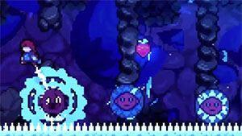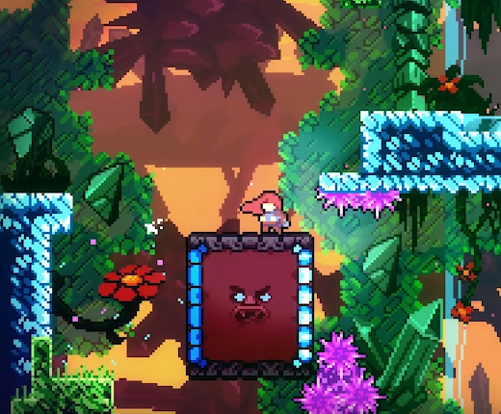

Right now, Matt Makes Games isn’t hiring right now as they are still a small company but I believe after the release of the hit game Celeste they will begin to grow.

### Game Programmer

Game Developers, like in the name develop games or at least the programming part of the game. Game developers have to be great at problem solving, as that is a big part of their job: finding and solving bugs. Developers have to think analytically and know how to efficiently fix bugs and various other issues. They also have to stay up to date on different techniques and programming languages.

To be a game programmer in the industry you should have a degree in physics, maths or computer science. Having a GCSE in computer science will help to, other than that you should know relevant software development techniques while also having knowledge in the programming language C++.

# Dream Job 3: Atlus (Level Designer)

I would like to work for this company specifically as a level designer on their game series called Persona designing the palaces which are like dungeons in Zelda with intricate puzzles and beautiful rooms filled with great art.



Unfortunately, they don’t have the job position I’m looking for so I would have to contact them about a possible job offer.

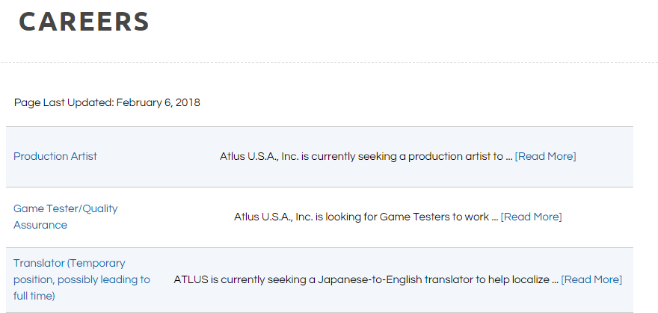

### Level Editor

The level editor will design the levels and maps of a game while also deciding the location and backdrop the level will have they also decide how hard the level should be, and how much the difficulty will increase throughout the game.

To be a level editor you don’t need any specific training and or qualifications although it is advised that you should have a decent understanding of popular programming languages while also being confident in drawing 3D models/sketches.

A brilliant level designer is Shinya Hiratake known for his contribution to the Mario franchise with Super Mario Galaxy 2, Super Mario 3D World and Land then finally Super Mario Odyssey.



# Business Card

I made this card on a free business card making website meaning there weren’t many options for designing causing the end result to be underwhelming. I will remake this card in the future when I have money and will actually be using them in a business fashion. A good business card should get right to the point and display your name, contact information and skills you have what would help you in a business relationship. An example of a good business card is the picture on the left from American Psycho, as you can see it is clear to the point and the background colour really emphasizes the bold black writing.

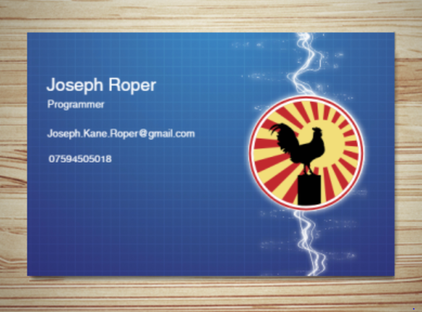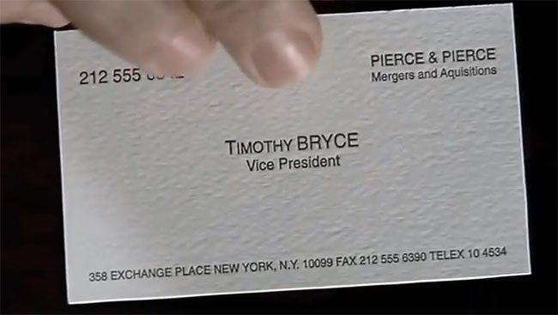

# Curriculum Vitae

A good CV should contain all of the skills you have which will be important in the workplace, while also displaying your work experience and qualifications. A CV should emphasize everything good about you so an employer will want to hire you the most out of every other applicant. The top picture is an example of a bad CV as it is really short and displays hardly any information. The CV on the bottom is my own personal CV, this is good as it clearly shows my skills that will help me in the workplace for future employers.

